Datasets and Data Frames:

URL = https://cf-courses-data.s3.us.cloud-object-storage.appdomain.cloud/IBM-DS0321EN-SkillsNetwork/datasets/dataset_part_2.csv

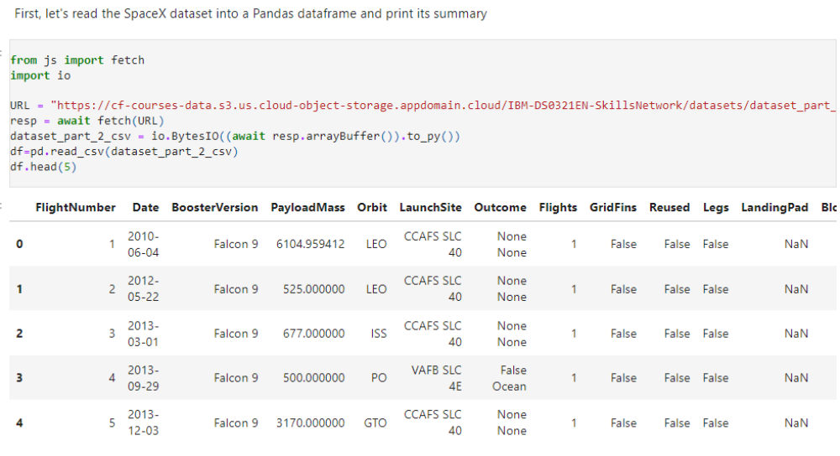

df=pd.read_csv("https://cf-courses-data.s3.us.cloud-object-storage.appdomain.cloud/IBM-DS0321EN-SkillsNetwork/datasets/dataset_part_2.csv")

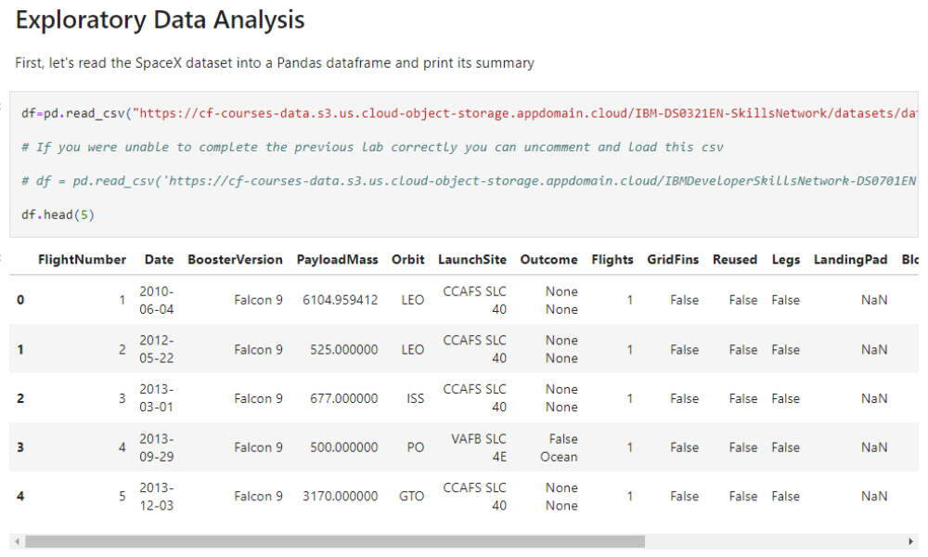

Web Scraping:
static_url = "https://en.wikipedia.org/w/index.php?title=List_of_Falcon_9_and_Falcon_Heavy_launches&oldid=1027686922"

After you have fill in the parsed launch record values into launch_dict, you can create a dataframe from it.
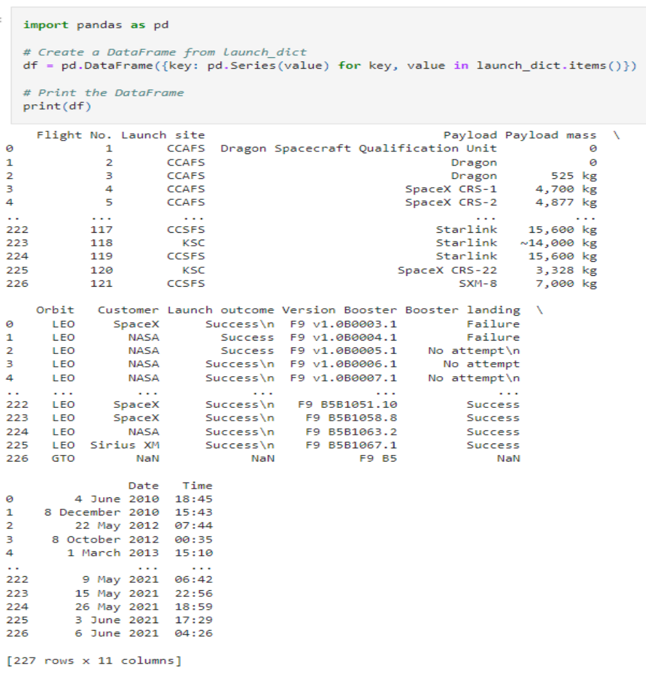

Dataset with the name spacex_launch_geo.csv

# Download and read the `spacex_launch_geo.csv`

spacex_csv_file = wget.download('https://cf-courses-data.s3.us.cloud-object-storage.appdomain.cloud/IBM-DS0321EN-SkillsNetwork/datasets/spacex_launch_geo.csv')
spacex_df=pd.read_csv(spacex_csv_file)

Now, you can take a look at what are the coordinates for each site.

